Q1 (a) 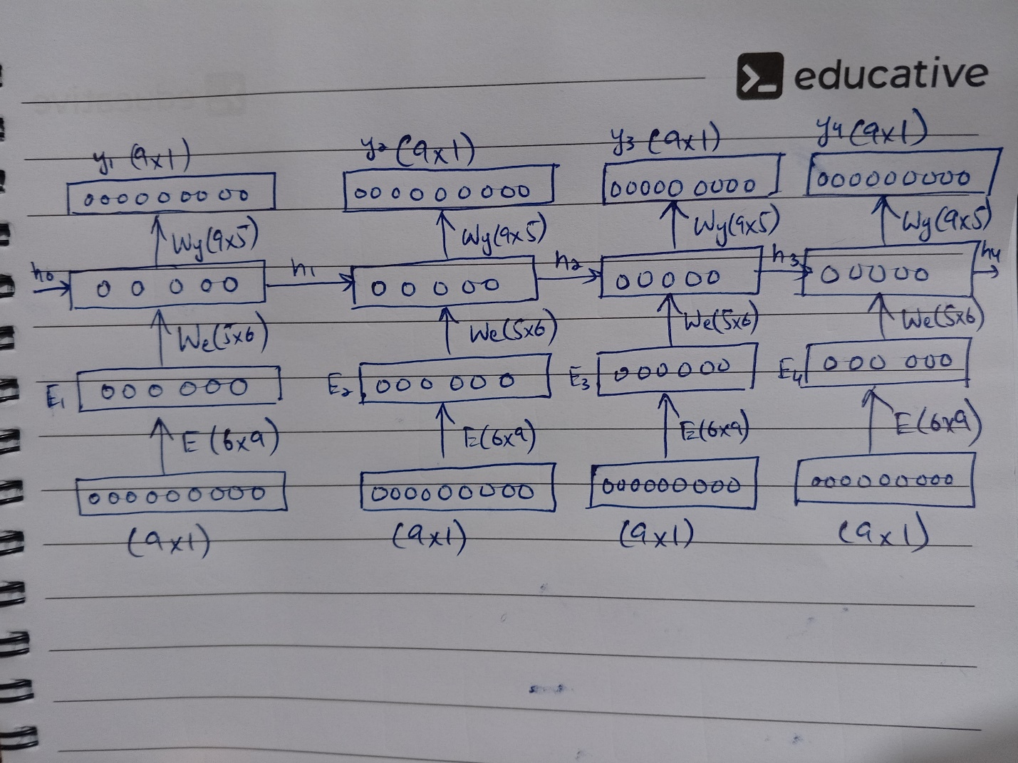

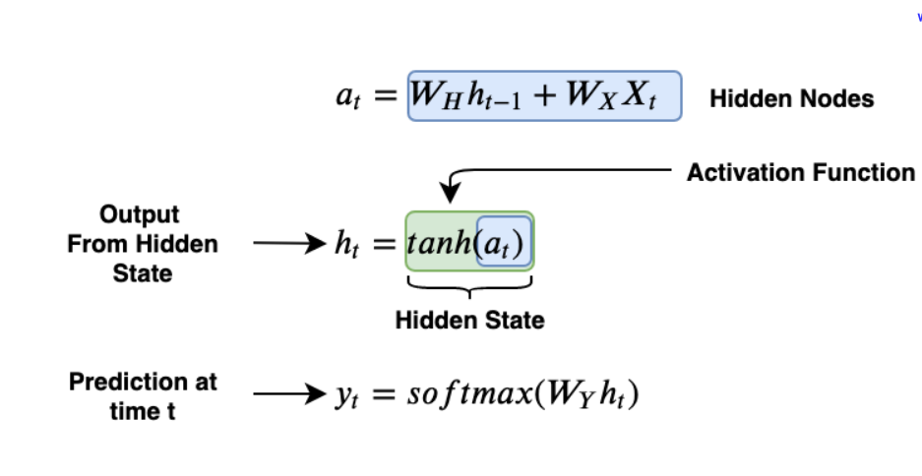

(b) Total Number of Parameters= (6\*9) +(5\*6) +(9\*5) +(5\*5) = 154

(c) Total Number of Parameters= 154, if the input sequence is increase to 10

Q2 (a)

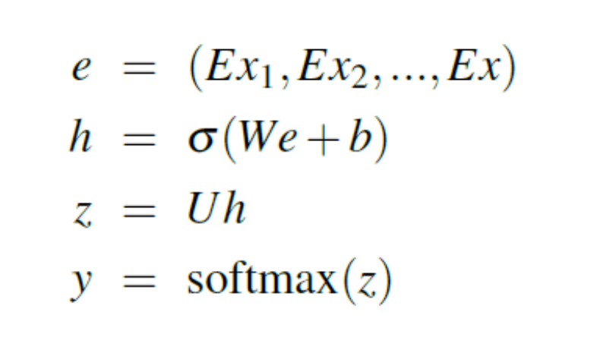

(b) Total Number of Parameters= (24\*5) + (5\*9) = 165

(c) Total Number of Parameters= (10\*6\*5) + (5\*9) = 345